**Project title :**

**Style with My Weather App (Erum, Dennis, Gregory, Quincy, )**

**Project description:**

Weather app that tells you how to dress based on the weather. Includes link to Google Map, nearby clothing stores, maybe Pinterest for latest styles.

**User Story:**

This website is primarily for tourist however, anyone can use it. It will help them to get the temperature, know how to dress, know nearby clothing stores, nearby restaurants, night life, and attractions to achieve a fun day roaming around their location. This website is beneficial because it includes everything they need to know to get through the city all in one website.

**Proposed CSS framework:**

Foundations

**Wireframe (sketch)**

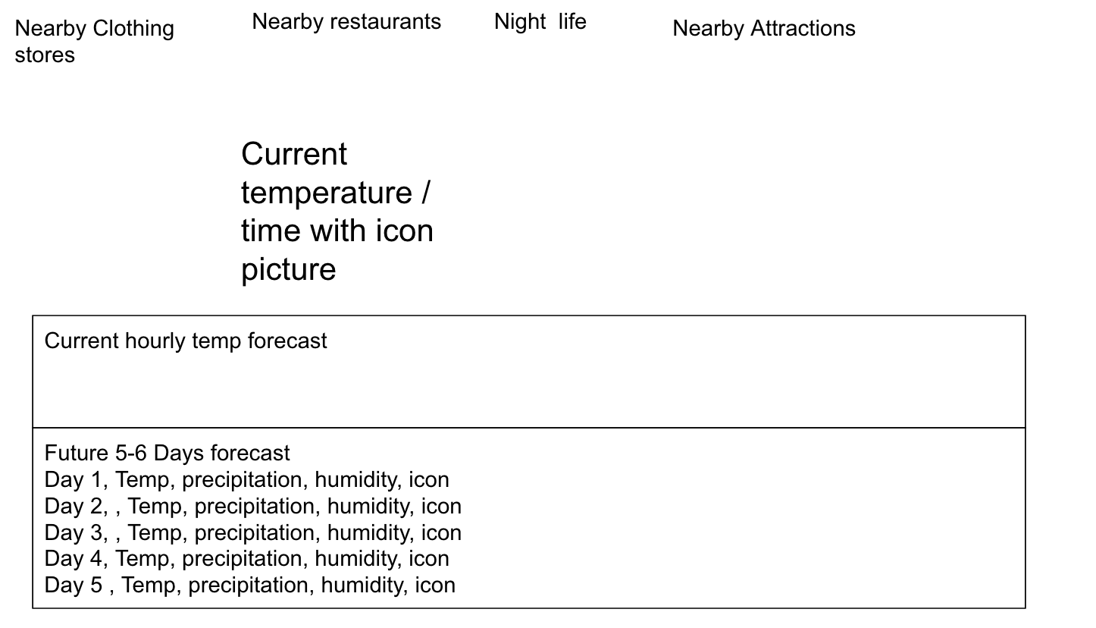

**APIs**

Open weather app.

Unsplash, GIPHY

Google Map

**Proposed Developer Roles:**

TBD, Front-End UI work, JavaScript Front-End, Project Management?

Erum

Dennis

Gregory

Quincy